<https://tpchd.org/healthy-homes/outdoor-air-quality/wildfire-smoke/>

[Home](https://tpchd.org/) » [Healthy Homes](https://tpchd.org/healthy-homes/) » [Outdoor Air Quality](https://tpchd.org/healthy-homes/outdoor-air-quality/) » **Wildfire Smoke**

**Wildfire Smoke**

**How to protect your health from the haze.**

You may have noticed wildfire smoke has become part of Pierce County summers in recent years. Climate change is linked to longer, warmer, and drier summers. These conditions lead to wildfires. This new problem might be a lasting problem.

Health effects from smoke can vary greatly from person to person. Smoke contains tiny particles that are bad for your lungs, heart, sinuses and other parts of your body. Those with underlying medical conditions like asthma feel them the most. But everybody should pay attention to their own health when smoke is in the air.

Check with [Puget Sound Clean Air Agency](https://pscleanair.org/) or [Washington Smoke Information](https://wasmoke.blogspot.com/) for current conditions.

**Create a clean room**

Smoke from fires can make outdoor air unhealthy. Actions that project your health from wildfire smoke can also project you during any smoke events.

A clean air room can help reduce your exposure to wildfire, or other types of smoke while indoors. This should be a room large enough for everyone in your household, and comfortable for extended periods of time. You should close windows and doors to keep air in the room isolated from the rest of the house.

If you have an HVAC system, the Environmental Protection Agency recommends you use a high-efficiency filter—MERV 13 or higher. If you don’t have an HVAC system, use an air cleaner with a HEPA filter or make your own [Box Fan Filter](https://www.youtube.com/watch?v=ujUFj2G9_-Y). [Learn more about how to create a clean room](https://www.epa.gov/indoor-air-quality-iaq/create-clean-room-protect-indoor-air-quality-during-wildfire).

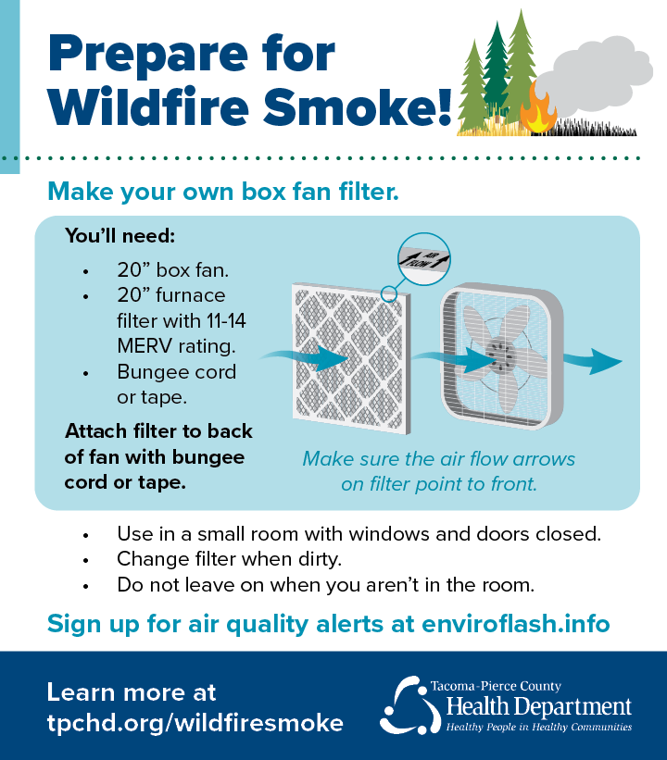

**Smoke gets in your eyes (and lungs, and sinuses…)**

When it’s smoky, take charge of your health:

* Check air quality before you’re active outside.
* Limit time outdoors on poor air quality days.
* Keep windows and doors closed.
* Run an air conditioner on recirculate to avoid bringing in outside air.
* Use an air cleaner with a HEPA filter or make your own [Box Fan Filter](https://www.youtube.com/watch?v=ujUFj2G9_-Y).
* Don’t pollute your indoor air.  Avoid candles, incense, fireplaces, gas stoves and frying food.
* Don’t smoke.
* Consider leaving the area if the air quality is poor and it’s not possible to keep indoor air clean.
* If you have asthma or COPD, have an action plan. Talk with your healthcare provider to prepare for poor air quality days.
* Don’t vacuum. It stirs up dust and smoke particles.

[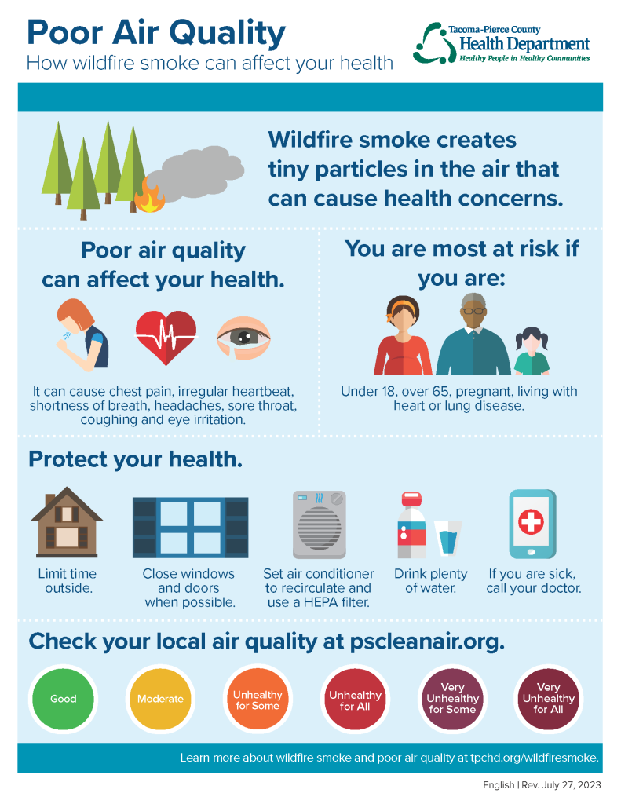](https://tpchd.org/wp-content/uploads/2023/12/Poor-Air-Quality-How-Wildfire-Smoke-Can-Affect-Your-Health.pdf)

**View how wildfire smoke can affect your health.**

Available in [English](https://tpchd.org/wp-content/uploads/2023/12/Poor-Air-Quality-How-Wildfire-Smoke-Can-Affect-Your-Health.pdf) | [Español (Spanish)](https://tpchd.org/wp-content/uploads/2023/12/Poor-Air-Quality-How-Wildfire-Smoke-Can-Affect-Your-Health-Spanish.pdf) | [អក្សរខ្មែរ (Khmer)](https://tpchd.org/wp-content/uploads/2023/12/Poor-Air-Quality-How-Wildfire-Smoke-Can-Affect-Your-Health-Khmer.pdf" \t "_blank) | [Tagalog (Filipino)](https://tpchd.org/wp-content/uploads/2023/12/Poor-Air-Quality-How-Wildfire-Smoke-Can-Affect-Your-Health-Tagalog.pdf) | [한국어 (Korean)](https://tpchd.org/wp-content/uploads/2023/12/Poor-Air-Quality-How-Wildfire-Smoke-Can-Affect-Your-Health-Korean.pdf) | [Русский (Russian)](https://tpchd.org/wp-content/uploads/2023/12/Poor-Air-Quality-How-Wildfire-Smoke-Can-Affect-Your-Health-Russian.pdf" \t "_blank) | [Gagana fa’a Samoa (Samoan)](https://tpchd.org/wp-content/uploads/2023/12/Poor-Air-Quality-How-Wildfire-Smoke-Can-Affect-Your-Health-Samoan.pdf) | [Українська (Ukrainian)](https://tpchd.org/wp-content/uploads/2023/12/Poor-Air-Quality-How-Wildfire-Smoke-Can-Affect-Your-Health-Ukrainian.pdf" \t "_blank) | [Tiếng Việt (Vietnamese)](https://tpchd.org/wp-content/uploads/2023/12/Poor-Air-Quality-How-Wildfire-Smoke-Can-Affect-Your-Health-Vietnamese.pdf" \t "_blank).

Use your best common sense. If it looks and smells smoky outside, don’t go for a run, mow the lawn, or allow children to play outdoors.

Listen to your body. You might have:

* Itchy or burning eyes.
* Sore throat.
* Sinus congestion.
* Headaches.
* Heart palpitations.
* Shortness of breath.
* Coughing.

**When you should worry**

If you have heart or lung disease, those might get worse.

Smoke can also cause serious problems for sensitive groups like children, pregnant women and the elderly. Children breathe more air per pound of body weight, and their lungs are still developing.

Other groups at higher risk include people who are obese, who smoke or have:

* Lung diseases such as asthma and COPD.
* Respiratory infections, such as pneumonia, acute bronchitis, colds and flu.
* Existing heart or circulatory problems.
* Prior history of heart attack and stroke.
* Diabetes.
* COVID-19.

If you’re in one of those groups and worried about your symptoms, talk to your healthcare provider. If you have shortness of breath, wheezing, chest pain, heart palpitations, extreme fatigue or difficulty moving, contact your healthcare provider immediately or call 911.

**Recommendations for businesses**

* [L&I rules to protect workers from wildfire smoke](https://content.govdelivery.com/accounts/WADLI/bulletins/2e8733a).
* [DOH guidance for improving ventilation and indoor air quality](https://doh.wa.gov/sites/default/files/legacy/Documents/Pubs/333-208.pdf).
* Monitor air quality and modify activities as needed to protect employees and customers.
* During times of unhealthy air quality, everyone may begin to experience health effects and members of sensitive groups may experience more serious health effects.
* Keep doors and windows closed when possible.
* Run an air conditioner (if you have one) and set it to re-circulate.
* A HEPA air cleaner can help. Avoid air cleaners with ionizing or electrostatic features.

**Recommendations for schools**

* [Department of Health guidance during wildfire smoke events.](https://doh.wa.gov/sites/default/files/legacy/Documents/Pubs/333-208.pdf)
* [DOH: Air pollution and school activities.](https://doh.wa.gov/sites/default/files/legacy/Documents/Pubs/334-332.pdf)
* [Science in Action: How to build a Corsi-Rosenthal Box.](https://engineering.ucdavis.edu/news/science-action-how-build-corsi-rosenthal-box)

**Know what air quality means to you**

Washington State Department of Ecology’s [Air Quality Index (AQI)](https://ecology.wa.gov/Research-Data/Monitoring-assessment/Air-Quality-Index) reports air quality. AQI information can help inform you about air quality levels. When there is too much air pollution, your health could be at risk.

| **Color** | **Air pollution category** | **Meaning** | **Precaution to take** |
| --- | --- | --- | --- |
| Green | Good | Air pollution is minimal and there is little health risk. | None. |
| Yellow | Moderate | People with:  • Asthma. • Respiratory infections. • Diabetes. • Heart or lung disease. • Those who have had a stroke.  These people may begin to have breathing problems. | People with:  • Asthma. • Respiratory infections. • Diabetes. • Heart or lung disease. • Those who have had a stroke.  These people should limit outdoor activities or do activities that take less effort, such as walking instead of running. |
| Orange | Unhealthy for Sensitive Groups | More people than average may have breathing problems or have worsened symptoms of existing asthma or lung disease. | Sensitive groups include:  • People with heart or lung disease. • Asthma. • Diabetes. • Infants and children. • Adults older than 65. • Pregnant women. • Those who have had a stroke.  These people should limit time spent outdoors. |
| Red | Unhealthy for Everyone | Many more people than average may have breathing problems or have worsened symptoms of existing lung or heart disease. | Everyone, especially sensitive groups, should:  • Limit time spent outdoors. • Avoid exercising outdoors (including sports teams). • Choose non-strenuous indoor activities. |
| Purple | Very Unhealthy for Everyone | Some healthy people may have breathing problems. People with asthma, lung and heart disease have an increased risk of symptoms or worsening of their disease. Studies show that hospitalizations increase by 50 percent for people with lung diseases. | Everyone should:  • Stay indoors.  • Do only light indoor activities.  • Keep windows closed if it is not too hot. • Run air conditioners on re-circulate. • Close the outside air intake. • Use indoor air cleaners with HEPA filters, if available. • Wear an N-95 respirator mask, if you must be outdoors. People with chronic diseases should check with their health care provider before wearing a mask.  People with asthma, lung and heart disease, or who have had a stroke should check with their healthcare provider for advice about leaving the area. Anyone with shortness of breath, wheezing, chest pain, heart palpitations, extreme fatigue, or difficulty moving or speaking should call their healthcare provider or call 911. |
| Dark Red | Hazardous | More healthy people are likely to have breathing problems. The people most susceptible are:  • People with heart or lung disease. • Asthma. • Diabetes. • Infants and children. • Adults older than 65. • Pregnant women. • Those who have had a stroke.  Studies suggest more people with asthma, lung or heart disease need medical attention. | Everyone should:  • Stay indoors.  • Do only light activities.  • Keep windows closed if it is not too hot. • Run air conditioners on re-circulate. • Close the outside air intake. • Use indoor air cleaners with HEPA filters, if available. • Wear an N-95 respirator mask, if you must be outdoors. People with chronic diseases should check with their health care provider before wearing a mask.  Check with your local health department for health information. People with asthma, heart or lung disease, or who have had a stroke should check with their healthcare provider for advice about leaving the area. Anyone with shortness of breath, wheezing, chest pain, heart palpitations, extreme fatigue, or difficulty moving or speaking should call their healthcare provider or call 911. |

**Outdoor Air Quality FAQs**

[a](https://tpchd.org/healthy-homes/outdoor-air-quality/wildfire-smoke/)

**[What makes air quality unhealthy?](https://tpchd.org/healthy-homes/outdoor-air-quality/wildfire-smoke/)**

[a](https://tpchd.org/healthy-homes/outdoor-air-quality/wildfire-smoke/)

**[How can I protect myself and my family?](https://tpchd.org/healthy-homes/outdoor-air-quality/wildfire-smoke/)**

[a](https://tpchd.org/healthy-homes/outdoor-air-quality/wildfire-smoke/)

**[Should my child play or practice sports outside?](https://tpchd.org/healthy-homes/outdoor-air-quality/wildfire-smoke/)**

[a](https://tpchd.org/healthy-homes/outdoor-air-quality/wildfire-smoke/)

**[How can I learn about current air quality?](https://tpchd.org/healthy-homes/outdoor-air-quality/wildfire-smoke/)**

[a](https://tpchd.org/healthy-homes/outdoor-air-quality/wildfire-smoke/)

**[Should I wear a mask?](https://tpchd.org/healthy-homes/outdoor-air-quality/wildfire-smoke/)**

**Resources**

* [Washington Department of Health Air Quality Guide for School and Child Care Activities](https://doh.wa.gov/sites/default/files/legacy/Documents/Pubs/334-332.pdf).
* [Washington Department of Health Wildfire Toolkit:](https://doh.wa.gov/community-and-environment/air-quality/smoke-fires) Has educational handouts and information available in 11 languages.
* [Washington Smoke Information:](https://wasmoke.blogspot.com/) Shared information from agencies affected by wildfire smoke.
* [Washington Department of Ecology](https://ecology.wa.gov/Air-Climate/Air-quality/Smoke-fire/Health-effects): Smoke health effects and burning alternatives.
* [Poor Air Quality and Your Health](https://tpchd.org/healthy-homes/outdoor-air-quality/)[:](https://tpchd.org/healthy-homes/outdoor-air-quality/wildfire-smoke/) Do your part to keep our air clean.
* [Your Reliable Source Blog](https://tpchd.org/healthy-people/diseases/your-reliable-source-bulletin/) Look for news and updates when air quality is unhealthy.
* [Summary Guidance for Canceling Outdoor Events](https://doh.wa.gov/sites/default/files/legacy/Documents/4300/334-430-WIldfireSmokeOUTDOORSummary.pdf).
* [Summary Guidance for School Closures](https://doh.wa.gov/sites/default/files/legacy/Documents/4300/334-431-WIldfireSmokeSCHOOLSummary.pdf).
* [Ready Wrigley Prepares for Wildfires & Smoke](https://www.cdc.gov/orr/readywrigley/documents/CDC_CPR_RW_Prepares-for-Wildfires_FINAL.pdf)—Get tips, activities, and stories to help the whole family prepare for emergencies from Centers for Disease Control and Prevention.